
Artificial intelligence
(LAB)


Submitted By:
Name: Maira
Roll No: 249
Section: BSAI-3D

Submitted To:
Sir Rasikh

Task 1: Manual BFS and DFS Trace
Given Graph:
The following graph is used to perform BFS and DFS. The starting node is A, and the goal node is G.
A

B
C

F
E
D

G

1. Breadth-First Search (BFS)
BFS visits nodes level by level. It uses a queue, which follows the First In, First Out (FIFO) rule.
Step | Processed Node | Path | Queue after processing
Initial | — | — | A
1 | A | A | B, C
2 | B | A → B | C, D, E
3 | C | A → C | D, E, F
4 | D | A → B → D | E, F
5 | E | A → B → E | F, G
6 | F | A → C → F | G
7 | G | A → B → E → G | Empty

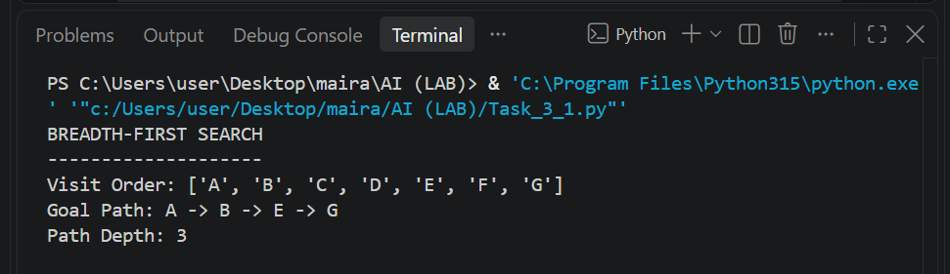

BFS Result:
Visit Order: A, B, C, D, E, F, G
Goal Path: A → B → E → G
Path Depth: 3

2. Depth-First Search (DFS)
DFS explores one branch as far as possible before moving to another branch. It uses a stack, which follows the Last In, First Out (LIFO) rule. Successors are pushed in reverse order to maintain the given visiting order.

DFS Manual Trace:

Step | Processed Node | Path | Stack After Processing
Initial | — | — | A
1 | A | A | C, B
2 | B | A → B | C, E, D
3 | D | A → B → D | C, E
4 | E | A → B → E | C, G
5 | G | A → B → E → G | C
Note: The top of the stack is on the right side.
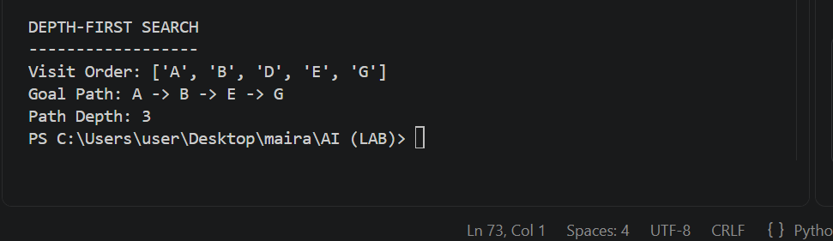

DFS Result:
Visit Order: A, B, D, E, G
Goal Path: A → B → E → G
Path Depth: 3 edges

- DFS reaches the goal by exploring the left branch first. It stops when G is processed.

3. Comparison of BFS and DFS:
Feature | BFS | DFS
Data Structure | Uses a queue (FIFO). | Uses a stack (LIFO).
Traversal | Visits nodes level by level. | Explores one branch at a time.
Shortest Path | Finds the shortest path in an unweighted graph. | Does not always find the shortest path.
Nodes Visited | 7 nodes. | 5 nodes.
Memory Usage | Generally requires more memory. | Generally requires less memory.
Conclusion:
Both BFS and DFS successfully found the goal node G in the given graph. Both algorithms returned the same path: A → B → E → G, with a depth of 3 edges. However, their visiting orders were different. BFS visited all nodes level by level, while DFS explored one branch before moving to another. BFS visited 7 nodes, whereas DFS reached the goal after visiting only 5 nodes. This shows how different search strategies can find the same solution using different approaches.

Task 2: Depth-Limited Search (DLS) and Iterative Deepening DFS (IDDFS)
1. Introduction:
Depth-Limited Search (DLS) works like DFS but searches only up to a fixed depth limit. It prevents the search from going too deep. Iterative Deepening DFS (IDDFS) repeats DLS with increasing depth limits until the goal is found.
Search Statuses:
- FOUND: The goal node has been reached.
- CUTOFF: The depth limit prevents the search from going further.
- FAILURE: No solution is found, and no unexplored nodes remain.

2. DLS Results:
The given graph was used with A as the starting node and G as the goal. The root node A is counted at depth 0.
Depth Limit | Status | Path
1 | CUTOFF | Not found
2 | CUTOFF | Not found
3 | FOUND | A → B → E → G
4 | FOUND | A → B → E → G

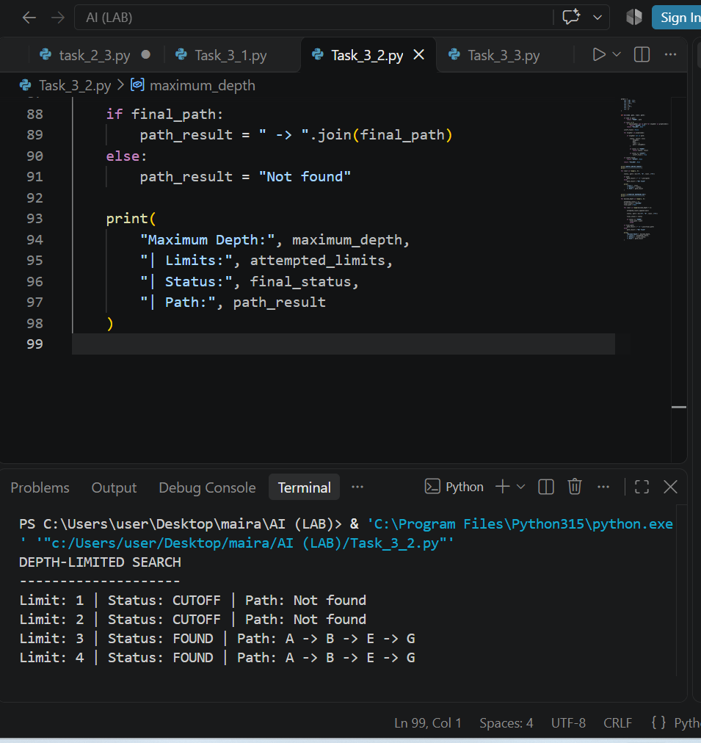

Explanation:
At limits 1 and 2, DLS could not reach the goal because G is at depth 3. At limits 3 and 4, it successfully found the goal.
3. IDDFS Results:
IDDFS gradually increases the depth limit and performs DLS again at each level.
Maximum Depth | Limits Attempted | Status | Path
1 | 0, 1 | CUTOFF | Not found
2 | 0, 1, 2 | CUTOFF | Not found
3 | 0, 1, 2, 3 | FOUND | A → B → E → G
4 | 0, 1, 2, 3 | FOUND | A → B → E → G

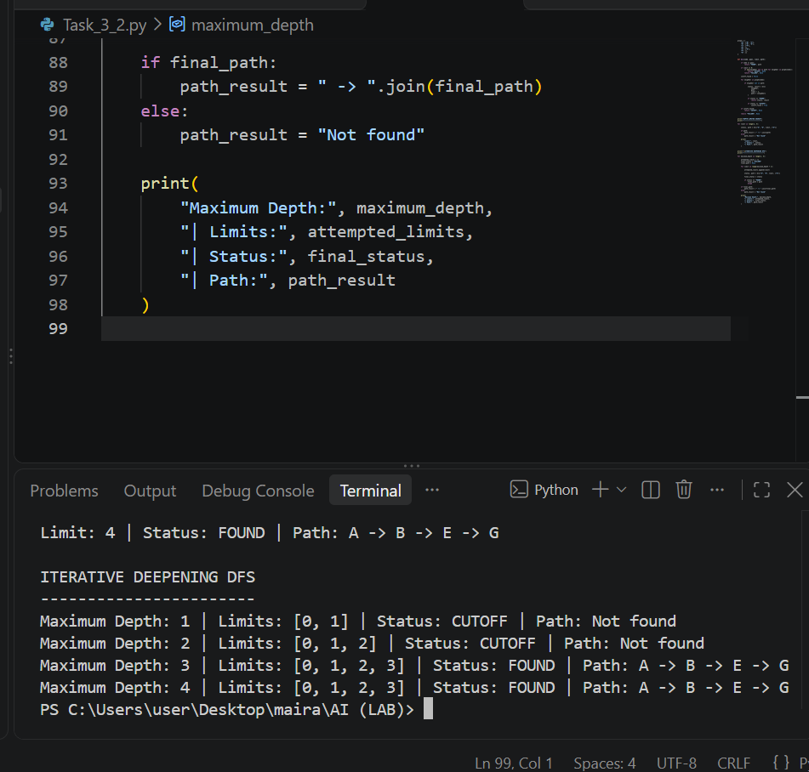
Explanation:
IDDFS starts with a small depth limit and increases it step by step. It finds the goal when the limit reaches 3. For maximum depth 4, it also finds the goal at depth 3, so no further search is needed.
4. Difference Between DLS and IDDFS:

DLS | IDDFS
Uses a fixed depth limit. | Increases the depth limit gradually.
May miss a goal beyond its limit. | Can find a goal by increasing the limit.
Does not repeat earlier searches. | Repeats searches at earlier depths.

5. Conclusion:
DLS found the goal when the depth limit reached 3. IDDFS also found the goal by gradually increasing its search limit. Both methods are useful when searching through graphs with limited depth.
Task 3: Uniform Cost Search (UCS)
1. Introduction:
Uniform Cost Search (UCS) finds the path with the lowest total cost from the start node to the goal node. It uses a priority queue and expands the node with the lowest path cost first.
2. Weighted Graph:
The graph contains the following weighted edges:
Edge | Cost
A → B | 2
A → C | 5
B → D | 4
C → D | 1
D → G | 3
B → G | 10
Start Node: A
Goal Node: G
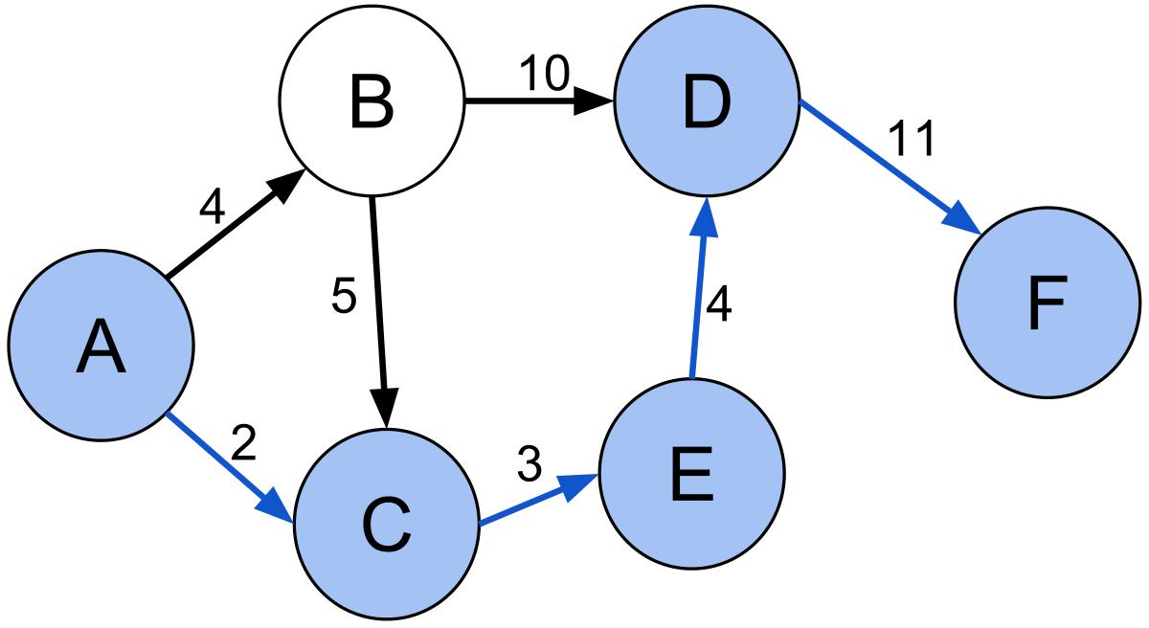
3. UCS Processing Order:
UCS processes nodes according to their cumulative path cost.
Step | Processed Node | Path Cost
1 | A | 0
2 | B | 2
3 | C | 5
4 | D | 6
5 | G | 9

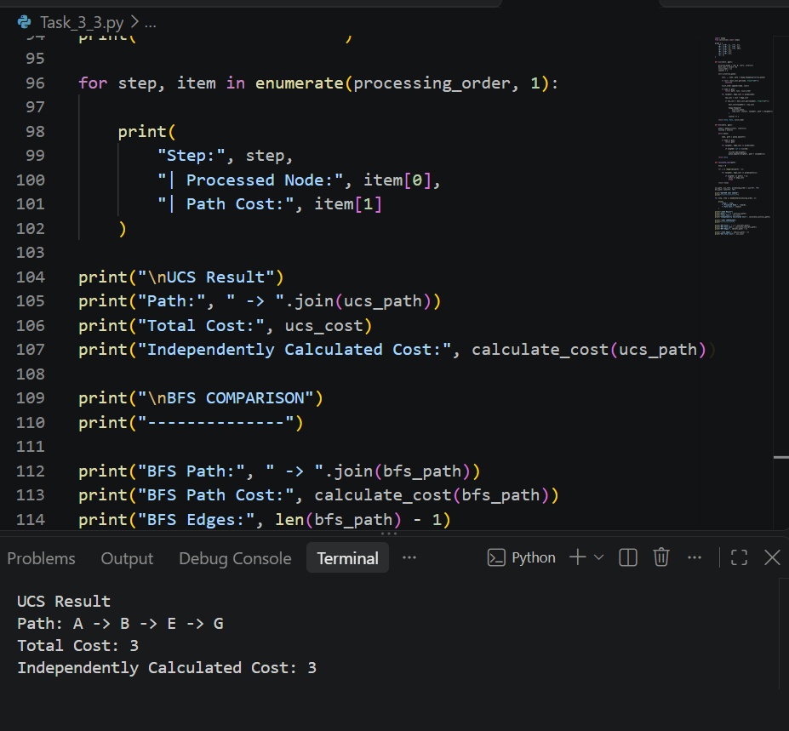

4. Final UCS Path and Cost:
Optimal Path:
A → B → D → G
Total Cost:
2 + 4 + 3 = 9
Therefore, the minimum-cost path from A to G is A → C → D → G, with a total cost of 9.
BFS Route Comparison:
Using BFS on the same weighted graph, the route is:
A → B → G
Total Cost = 2 + 10 = 12
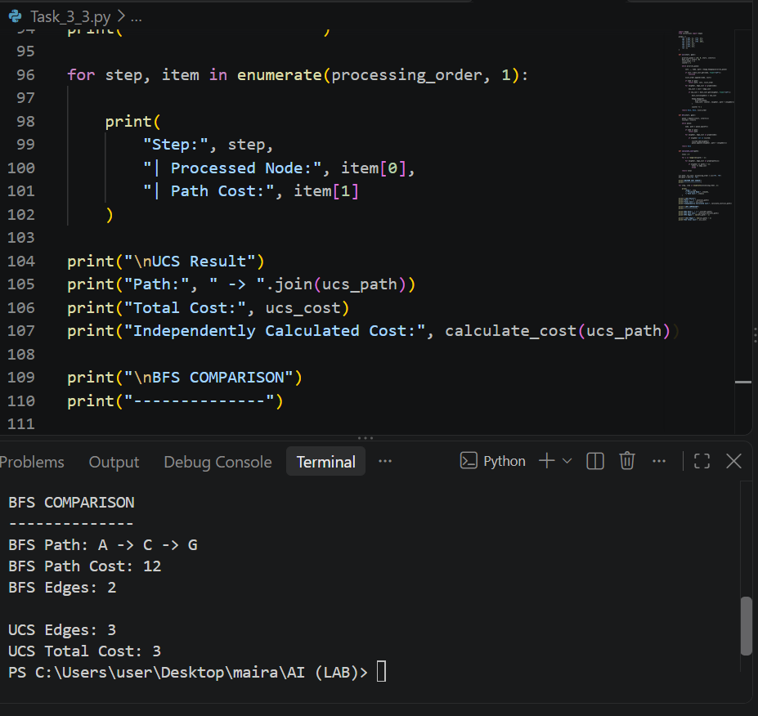
UCS finds a different route:
A → B → D → G
Total Cost = 2 + 4 + 3 = 9
Explanation:
BFS selects the route with fewer edges without considering their costs. UCS considers the total cost and finds the cheaper route. Therefore, BFS uses 2 edges with a cost of 12, while UCS uses 3 edges with a lower cost of 9.

Feature | BFS | UCS
Selection | Shallowest node first | Lowest-cost node first
Uses edge costs | No | Yes
Main purpose | Finds the path with the fewest edges | Finds the path with the lowest total cost
5. Comparison of UCS and BFS:

BFS may select a path with fewer edges even if its total cost is higher. UCS considers the cost of every edge and selects the minimum-cost path.
6. Conclusion:
UCS is useful when paths have different costs. It finds the least-cost path by expanding the node with the lowest cumulative cost instead of simply choosing the path with the fewest edges.

Step | Processed Node | Path | Stack after processing
Initial | — | — | A
1 | A | A | C, B
2 | B | A → B | C, E, D
3 | D | A → B → D | C, E
4 | E | A → B → E | C, G
5 | G | A → B → E → G | C

DFS Result:
Visit Order: A, B, D, E, G
Goal Path: A → B → E → G
Path Depth: 3
3. Comparison of BFS and DFS
BFS | DFS
Uses a queue (FIFO). | Uses a stack (LIFO).
Visits nodes level by level. | Explores one branch at a time.
Finds the shortest path in terms of edges for this unweighted graph. | Does not always find the shortest path.
Visits 7 nodes. | Visits 5 nodes.

Conclusion
Both BFS and DFS successfully found the goal node G. In this graph, both algorithms returned the same path: A → B → E → G. BFS checked more nodes, while DFS reached the goal by exploring one branch first.
One important note: In the DFS table, the top of the stack is on the right side. This explains why B is processed before C.
This completes the written manual-trace portion of Task 1. The Python verification is also required by your lab, but we'll handle that as the next part of this same task.

